Spencer Schwellenbach 2024

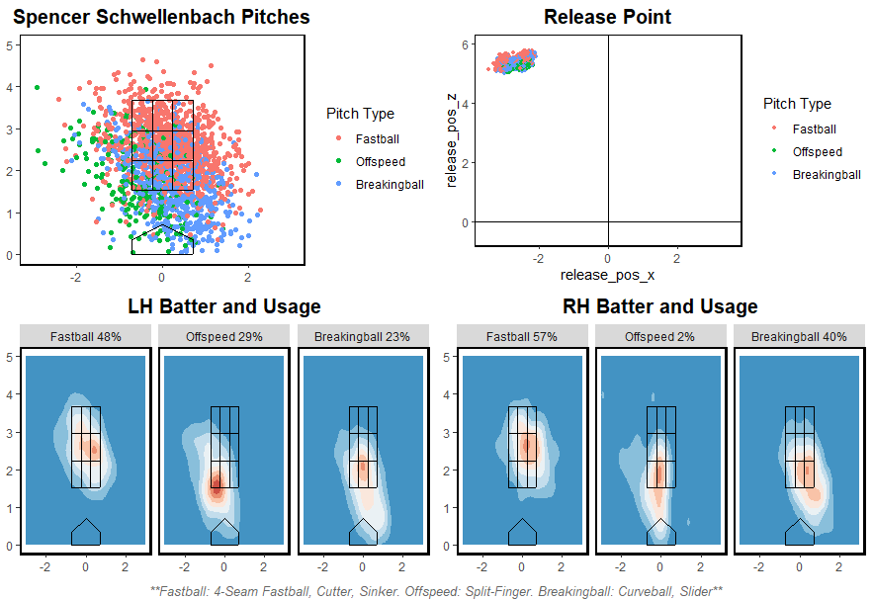

Spencer Schwellenbach had a great rookie year having his first start for the Atlanta Braves on May 29th against the Nationals. Spencer is a young prospect for the Braves looking to make an impact on the upcoming years. As a Fastball dominant pitcher touching upper 90s and a breaking ball slider that sweeps to the batters feet at mid 80s. He will be exciting to see as he progresses into the majors.

One thing I did notice at first glance was his range of his release point. From all his pitches of 2024 it looks like his release point was all over the place, so I did a little more digging and discovered the Braves had made an adjustment. Those pitches from the visual below are from before and after his fifth start of the year. You can see they are much more clumped together as they should be for a major league starter.

